Chapter 9 Testing
Link to GitHub and Path for Chapter 9 Folder
https://github.com/jocooper317/SDEV153-WebPage.git
https://jocooper317.github.io/SDEV153-WebPage/
Testing Verifications –
Chapter 9 CSS W3C Validation –
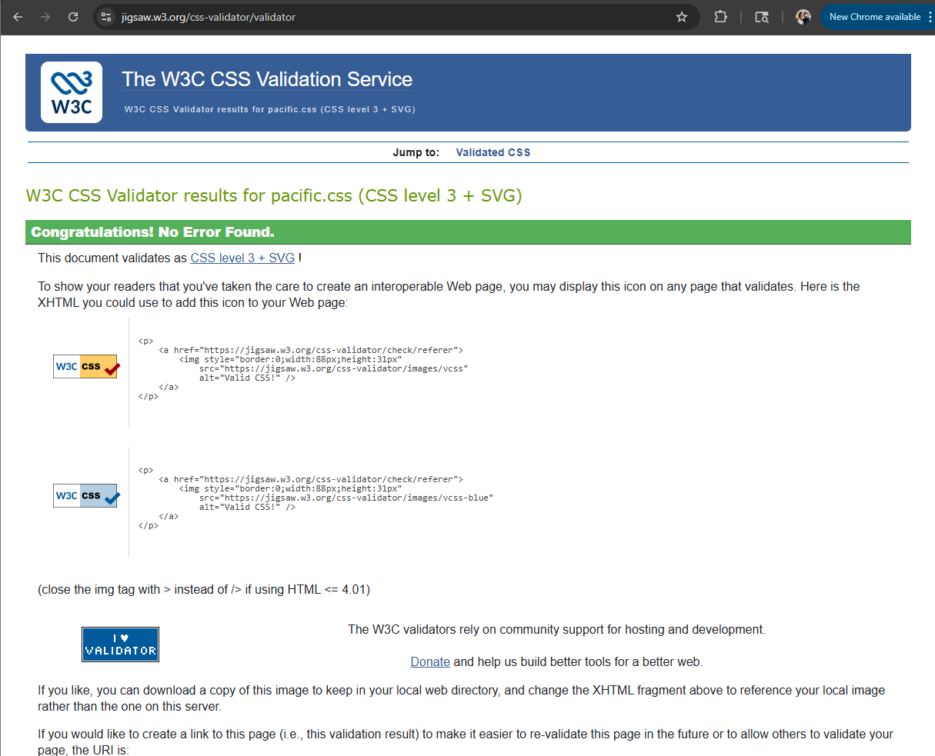
Chapter 9 Yurts.html html validation –
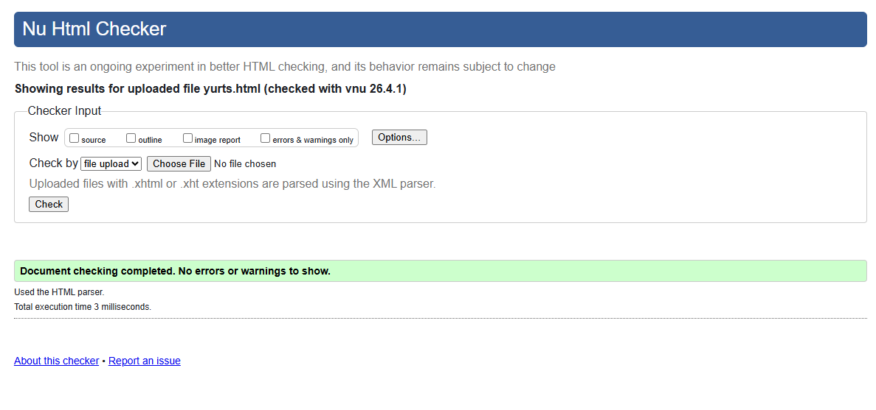
Chapter 9 – Reservations.html testing
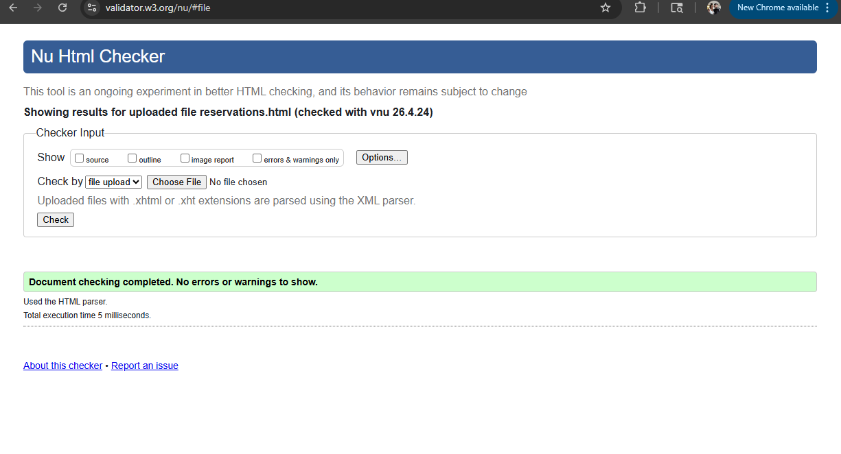
Yurts.html pop up testing –
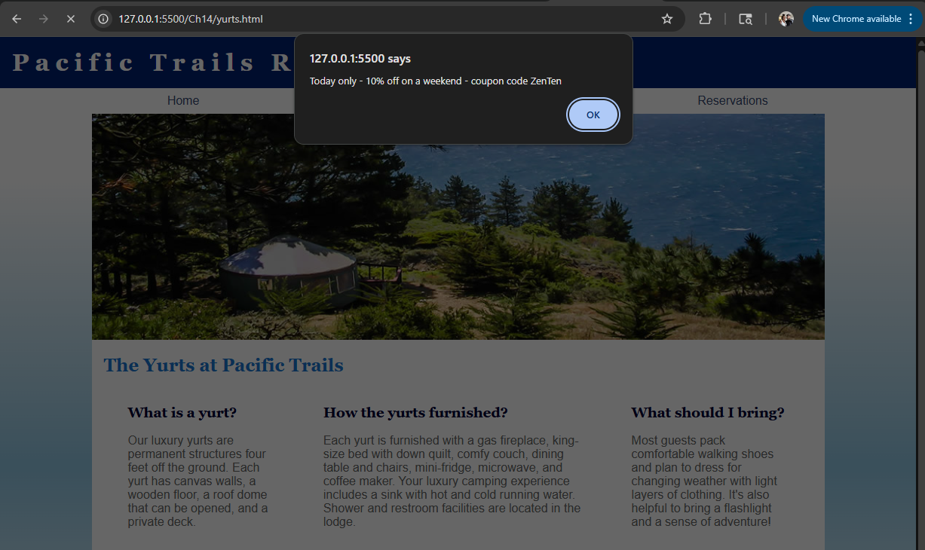
Reservations.html testing –
Filling out fields
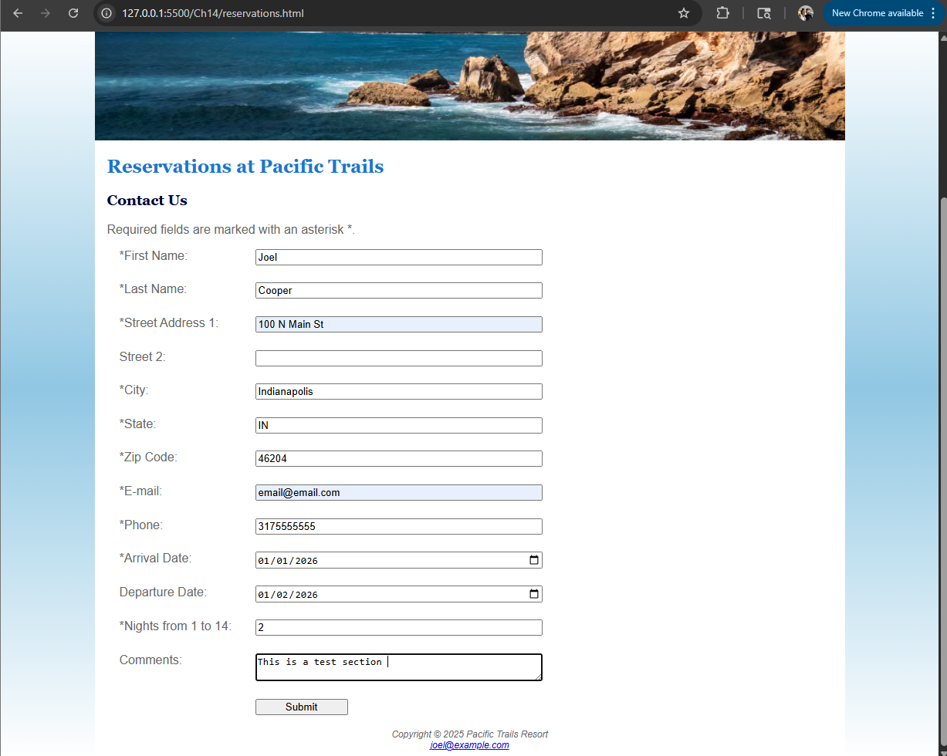
Submitted –
